
BRAINWARE UNIVERSITY
School of Engineering
Department of Computer Science & Engineering – Cyber Security & Data Science
398, Ramkrishnapur Road, Barasat, North 24 Parganas, Kolkata – 700 125

Title: Reliable data transfer system for online banking

Objective:
Analyse & implement suitable error detection, correction, flow control & error control mechanisms for reliable transmission of banking transaction data.

Real Life Connection:
An online banking system must transfer financial transaction data securely. A corrupted frame could result in incorrect transaction information; therefore, the network requires appropriate error detection, correction and transmission mechanisms to make a secure connection between client and server.

Target:
(i) Design the network for secure banking transaction among client and server using Cisco Packet Tracer.
(ii) Consider the data packet binary sequence is 1101011011; the generator polynomial is 10011. Identify the CRC code and demonstrate how the receiver detects an error. Recalculate the CRC at the receiver.
(iii) Determine whether the frame is accepted or rejected by the end user according to design.

Group Members
Member Name | Student Code
Kashif Iqbal | BWU/BTD/24/068
Soumen Jana | BWU/BTD/24/073
Soumen Das | BWU/BTD/24/074
Sudipta De | BWU/BTD/24/079
Subir Ghosh Gope | BWU/BTD/24/123

_____________________________________________________________________________

TABLE OF CONTENTS
1. Assignment Question.
2. Introduction.
3. Objectives.
4. Theoretical Background.
5. Proposed Cisco Packet Tracer Network.
6. IP Addressing Plan.
7. Router and WAN Configuration.
8. OSPF Routing Configuration.
9. End-Device Configuration.
10. Basic Security and ACL.
11. Network Verification and Testing.
12. Numerical CRC Calculation.
13. Receiver CRC Check and Error Demonstration.
14. Reliability and Security Integration.
15. Real-Life Observations.
16. Conclusion.
17. Future Scope.
18. References.

_______________________________________________________________________

1. ASSIGNMENT QUESTION
Objective
Analyse and implement suitable error detection, correction, and reliable transmission mechanisms for reliable transmission of banking transaction data.

Real-Life Connection
An online banking system must transfer financial transaction data securely. A corrupted frame could result in incorrect transaction information; therefore, the network requires suitable error detection and reliable transmission mechanisms to maintain correct communication between clients, branches, and banking servers.

Targets
• Design a network for secure banking transactions among clients and servers using Cisco Packet Tracer.
• Given data bits 1101011011 and generator polynomial 10011, calculate the CRC code and demonstrate how the receiver detects an error.
• Determine whether the frame is accepted or rejected according to the CRC result.

2. INTRODUCTION
Online banking depends on the correct movement of sensitive information between users, branch offices, and banking servers. A transaction can contain account details, transaction amount, and a transaction ID. If information is lost, changed, duplicated, or delivered incorrectly, the result can be serious.
This PBL project studies reliable data transfer from both the theoretical and practical sides. The theoretical part focuses on CRC, TCP reliability, and TLS-based security. The practical part uses Cisco Packet Tracer to model a banking network with one Head Office and two branch offices connected through serial WAN links.
The implemented network uses three routers, three LANs, two point-to-point WAN links, IPv4 addressing, and OSPF routing. The supplied verification results show successful WAN communication, reachable local gateways, and representative inter-LAN connectivity.

3. OBJECTIVES
• Understand why reliable data transfer is important in online banking.
• Use CRC to detect accidental transmission errors.
• Understand the role of reliable transport and retransmission in TCP.
• Understand how TLS provides confidentiality and cryptographic integrity for banking communication.
• Design and verify a multi-site banking network using Cisco Packet Tracer.
• Configure IPv4 addressing, serial WAN links, and OSPF routing.
• Test communication between Head Office, Branch A, and Branch B.

_______________________________________________________________________

4. THEORETICAL BACKGROUND
Reliable banking communication requires both detection of accidental transmission errors and protection of data against unauthorized modification or observation. The main mechanisms considered in this report are CRC at the error-detection level, TCP at the transport level, and TLS for secure application communication.

4.1 Error Detection
Error detection identifies whether transmitted data has been changed or corrupted. CRC is the main error-detection method used in this PBL.
4.2 Cyclic Redundancy Check (CRC)
The sender takes the original binary data, appends zeros according to the degree of the generator, and divides the resulting sequence by the generator using modulo-2 arithmetic. Modulo-2 subtraction is performed with XOR. The remainder becomes the CRC and is attached to the original data. At the receiver, the complete codeword is divided by the same generator. A zero remainder means the CRC check passes; a non-zero remainder means an error is detected.
4.3 Checksum
A checksum divides data into blocks and performs arithmetic operations on those blocks. The result is transmitted with the data and recalculated by the receiver. It is widely used in networking, while CRC is especially useful for detecting many link-level transmission errors.
4.4 Parity
Parity adds an extra bit so that the number of 1s follows a chosen rule, such as even parity. It is simple but cannot detect every possible error, so CRC is used as the main error-detection mechanism in this project.
4.5 Error Correction
Forward Error Correction (FEC) adds extra information that allows the receiver to detect and sometimes correct errors without retransmission. Hamming code is a basic example. For critical banking data, detecting corruption and obtaining the correct data again can be safer than guessing the original financial information.
4.6 Transmission Control Protocol (TCP)
TCP provides reliable transport of application data through sequence numbers, acknowledgements, retransmission, timers, checksums, flow control, and congestion control. If an expected acknowledgement is not received, TCP can retransmit the required data. This makes TCP suitable for applications where delivery must be dependable.
4.7 Transport Layer Security (TLS)
TLS protects application communication by providing encryption, authentication through certificates, and cryptographic integrity. In online banking, TLS is used with HTTPS to protect sensitive information while it travels between a client and the banking service. CRC and TLS have different purposes: CRC detects accidental transmission errors, while TLS provides cryptographic protection against unauthorized observation or modification.

_______________________________________________________________________

5. PROPOSED CISCO PACKET TRACER NETWORK
The practical network contains a Head Office and two branch offices. Each site has a switch and multiple end devices. R0 at the Head Office connects to R1 at Branch A and R2 at Branch B using two point-to-point serial WAN links.

5.1 Topology Components
• R0 – Head Office router (Cisco ISR4331)
• R1 – Branch A router (Cisco ISR4331)
• R2 – Branch B router (Cisco ISR4331)
• One 2960-24TT switch at each site
• Head Office: Banking Server, Database Server, Backup Server, Manager PC
• Branch A: ATM 1, Teller PC A1, Teller PC A2, Branch Manager PC A
• Branch B: ATM 2, Teller PC B1, Teller PC B2, Branch Manager PC B
• Two serial WAN links using /30 point-to-point networks.

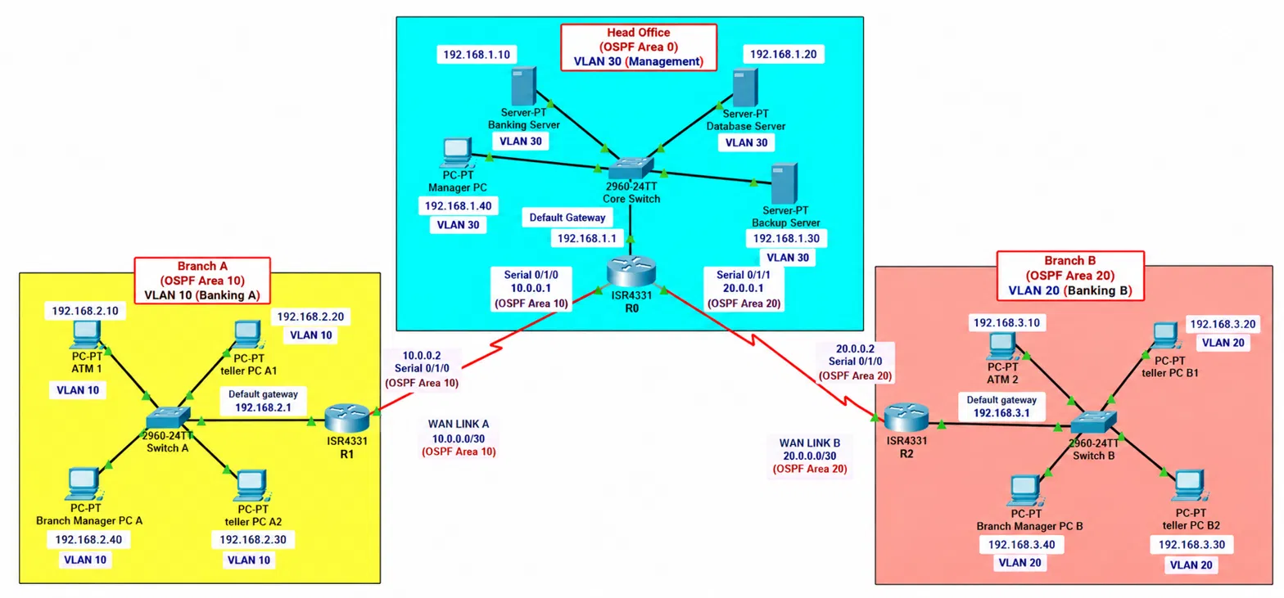
Figure 1. Cisco Packet Tracer topology used for the banking network.

5.2 Topology Summary
Head Office: 192.168.1.0/24 — Area 0 — VLAN 30 | Banking Site A: 192.168.2.0/24 — Area 10 — VLAN 10 | Banking Site B: 192.168.3.0/24 — Area 20 — VLAN 20
R0 connects to R1 through 10.0.0.0/30 in Area 10 and to R2 through 20.0.0.0/30 in Area 20. The Head Office LAN connected to R0 is in Area 0, making R0 an ABR. R1 keeps its LAN and WAN interfaces in Area 10, while R2 keeps its LAN and WAN interfaces in Area 20
_______________________________________________________________________
6. IP ADDRESSING PLAN
6.1 Router Interfaces
Router | Interface | Purpose | IP Address | Mask | DCE/DTE
R0 | G0/0/0 | Head Office LAN | 192.168.1.1 | 255.255.255.0 | LAN
R0 | S0/1/0 | WAN to R1 | 10.0.0.1 | 255.255.255.252 | DCE
R0 | S0/1/1 | WAN to R2 | 20.0.0.1 | 255.255.255.252 | DTE
R1 | G0/0/0 | Branch A LAN | 192.168.2.1 | 255.255.255.0 | LAN
R1 | S0/1/0 | WAN to R0 | 10.0.0.2 | 255.255.255.252 | DTE
R2 | G0/0/0 | Branch B LAN | 192.168.3.1 | 255.255.255.0 | LAN
R2 | S0/1/0 | WAN to R0 | 20.0.0.2 | 255.255.255.252 | DCE

6.2 End Devices
Site | Device | IP Address | Mask | Default Gateway
Head Office | Banking Server | 192.168.1.10 | 255.255.255.0 | 192.168.1.1
Head Office | Database Server | 192.168.1.20 | 255.255.255.0 | 192.168.1.1
Head Office | Backup Server | 192.168.1.30 | 255.255.255.0 | 192.168.1.1
Head Office | Manager PC | 192.168.1.40 | 255.255.255.0 | 192.168.1.1
Branch A | ATM 1 | 192.168.2.10 | 255.255.255.0 | 192.168.2.1
Branch A | Teller PC A1 | 192.168.2.20 | 255.255.255.0 | 192.168.2.1
Branch A | Teller PC A2 | 192.168.2.30 | 255.255.255.0 | 192.168.2.1
Branch A | Branch Manager PC A | 192.168.2.40 | 255.255.255.0 | 192.168.2.1
Branch B | ATM 2 | 192.168.3.10 | 255.255.255.0 | 192.168.3.1
Branch B | Teller PC B1 | 192.168.3.20 | 255.255.255.0 | 192.168.3.1
Branch B | Teller PC B2 | 192.168.3.30 | 255.255.255.0 | 192.168.3.1
Branch B | Branch Manager PC B | 192.168.3.40 | 255.255.255.0 | 192.168.3.1

The addressing plan separates the three site LANs and uses /30 networks for the two point-to-point serial links. The default gateway at each site is the LAN interface of its local router.
_______________________________________________________________________

7. ROUTER AND WAN CONFIGURATION
The verified Packet Tracer project uses the actual ISR4331 interface names below. Serial encapsulation remains the default HDLC. Clock rate is applied only to DCE interfaces.

7.1 R0 – Head Office
R0> enable
R0# configure terminal
R0(config)# interface gigabitEthernet 0/0/0
R0(config-if)# ip address 192.168.1.1 255.255.255.0
R0(config-if)# no shutdown
R0(config-if)# exit
R0(config)# interface serial 0/1/0
R0(config-if)# ip address 10.0.0.1 255.255.255.252
R0(config-if)# clock rate 2000000
R0(config-if)# no shutdown
R0(config-if)# exit
R0(config)# interface serial 0/1/1
R0(config-if)# ip address 20.0.0.1 255.255.255.252
R0(config-if)# no shutdown
R0(config-if)# exit
7.2 R1 – Branch A
R1> enable
R1# configure terminal
R1(config)# interface gigabitEthernet 0/0/0
R1(config-if)# ip address 192.168.2.1 255.255.255.0
R1(config-if)# no shutdown
R1(config-if)# exit
R1(config)# interface serial 0/1/0
R1(config-if)# ip address 10.0.0.2 255.255.255.252
R1(config-if)# no shutdown
R1(config-if)# exit
7.3 R2 – Branch B
R2> enable
R2# configure terminal
R2(config)# interface gigabitEthernet 0/0/0
R2(config-if)# ip address 192.168.3.1 255.255.255.0
R2(config-if)# no shutdown
R2(config-if)# exit
R2(config)# interface serial 0/1/0
R2(config-if)# ip address 20.0.0.2 255.255.255.252
R2(config-if)# clock rate 2000000
R2(config-if)# no shutdown
R2(config-if)# exit
DCE verification showed R0 S0/1/0 and R2 S0/1/0 as DCE with a 2,000,000 clock rate. R1 S0/1/0 and R0 S0/1/1 were DTE. All configured interfaces were verified as operational (up/up).

_______________________________________________________________________

8. OSPF ROUTING CONFIGURATION
The original static routes were removed from the three routers and replaced with OSPF so that the three-site network could exchange remote LAN routes dynamically. OSPF process 1 was configured in area 0 with a unique router ID on each router.

8.1 R0 – Head Office
R0(config)# router ospf 1
R0(config-router)# router-id 1.1.1.1
R0(config-router)# network 192.168.1.0 0.0.0.255 area 0
R0(config-router)# network 10.0.0.0 0.0.0.3 area 0
R0(config-router)# network 20.0.0.0 0.0.0.3 area 0
8.2 R1 – Branch A
R1(config)# router ospf 1
R1(config-router)# router-id 2.2.2.2
R1(config-router)# network 192.168.2.0 0.0.0.255 area 10
R1(config-router)# network 10.0.0.0 0.0.0.3 area 10
8.3 R2 – Branch B
R2(config)# router ospf 1
R2(config-router)# router-id 3.3.3.3
R2(config-router)# network 192.168.3.0 0.0.0.255 area 20
R2(config-router)# network 20.0.0.0 0.0.0.3 area 20
8.4 OSPF Verification
R0 reported both remote routers in the FULL state. R1 and R2 each reported R0 as a FULL OSPF neighbor. The routing tables also showed OSPF-learned routes to the remote LANs.
R0# show ip ospf neighbor
Neighbor ID Pri State Dead Time Address Interface
2.2.2.2 0 FULL/ - 00:00:36 10.0.0.2 Serial0/1/0
3.3.3.3 0 FULL/ - 00:00:36 20.0.0.2 Serial0/1/1
R0# show ip route
O 192.168.2.0/24 [110/65] via 10.0.0.2, Serial0/1/0
O 192.168.3.0/24 [110/65] via 20.0.0.2, Serial0/1/1
After verification, the running configurations were saved with copy running-config startup-config on R0, R1, and R2.

_______________________________________________________________________

9. END-DEVICE CONFIGURATION
End devices are configured through Packet Tracer Desktop → IP Configuration. The representative manager PCs use the following verified settings.
Device | IPv4 | Mask | Gateway | Gateway Test
Head Office Manager PC | 192.168.1.40 | 255.255.255.0 | 192.168.1.1 | PASS (4/4)
Branch Manager PC A | 192.168.2.40 | 255.255.255.0 | 192.168.2.1 | PASS (4/4)
Branch Manager PC B | 192.168.3.40 | 255.255.255.0 | 192.168.3.1 | PASS (4/4)

The screenshots supplied for this report confirm the IP address, subnet mask, and default gateway of the three representative manager PCs.

10. BASIC SECURITY AND ACL
The project uses ACL as a basic traffic-control design example. An extended ACL can permit HTTPS traffic from a banking client to the banking server and deny other direct IP traffic to that protected server.
Router(config)# ip access-list extended BANKING-ACL
Router(config-ext-nacl)# permit tcp host 192.168.1.40 host 192.168.1.10 eq 443
Router(config-ext-nacl)# deny ip any host 192.168.1.10
Router(config-ext-nacl)# permit ip any any
Router(config-ext-nacl)# exit

No ACL verification output was supplied in the completed Packet Tracer tests, so this section is treated as a security design/configuration example rather than a verified acceptance test. In a real banking network, firewalls, IDS/IPS, authentication, segmentation, logging, and TLS would be required in addition to router ACLs.

_______________________________________________________________________

11. NETWORK VERIFICATION AND TESTING

11.1 WAN Interface Verification
Interface | Status | Observation
R0 S0/1/0 | UP/UP | 10.0.0.1/30; HDLC; 0 CRC/input/output errors
R1 S0/1/0 | UP/UP | 10.0.0.2/30; HDLC; 0 CRC/input/output errors
R0 S0/1/1 | UP/UP | 20.0.0.1/30; HDLC; 0 CRC/input/output errors
R2 S0/1/0 | UP/UP | 20.0.0.2/30; HDLC; 0 CRC/input/output errors

11.2 WAN Ping Tests
Source | Destination | Result
R0 | 10.0.0.2 | PASS – 5/5, 100%
R0 | 20.0.0.2 | PASS – 5/5, 100%
R1 | 10.0.0.1 | PASS – 5/5, 100%
R2 | 20.0.0.1 | PASS – 5/5, 100%

11.3 Local Gateway Tests
Source | Gateway | Result
R0 | 192.168.1.1 | PASS – 5/5, 100%
R1 | 192.168.2.1 | PASS – 5/5, 100%
R2 | 192.168.3.1 | PASS – 5/5, 100%
Head Office Manager PC | 192.168.1.1 | PASS – 4/4, 0% loss
Branch Manager PC A | 192.168.2.1 | PASS – 4/4, 0% loss
Branch Manager PC B | 192.168.3.1 | PASS – 4/4, 0% loss

11.4 End-to-End Tests
Source | Destination | Result
Head Office Manager PC (192.168.1.40) | Branch Manager PC A (192.168.2.40) | PASS – 4/4, 0% loss
Head Office Manager PC (192.168.1.40) | Branch Manager PC B (192.168.3.40) | PASS – 4/4, 0% loss
Branch Manager PC A (192.168.2.40) | Branch Manager PC B (192.168.3.40) | PASS – 4/4, 0% loss

These are representative host-to-host tests. They demonstrate successful routing between all three LANs, but the report does not claim that every individual host was separately ping-tested.
_______________________________________________________________________

11. NETWORK VERIFICATION AND TESTING — EVIDENCE

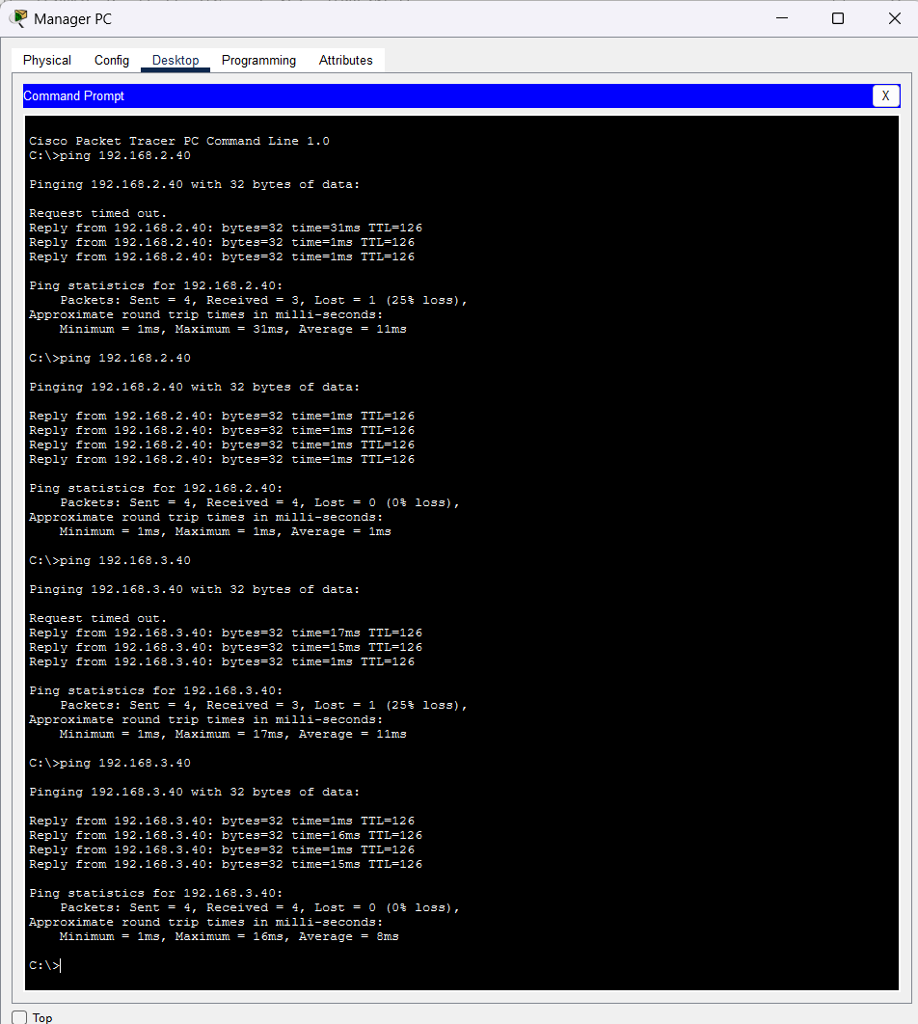

Figure 3. Head Office Manager PC: verified IP configuration and successful connectivity to Branch A and Branch B.

The initial timeout visible in the Packet Tracer host test is consistent with address-resolution setup; the repeated tests shown in the same evidence completed with 0% packet loss.

_______________________________________________________________________

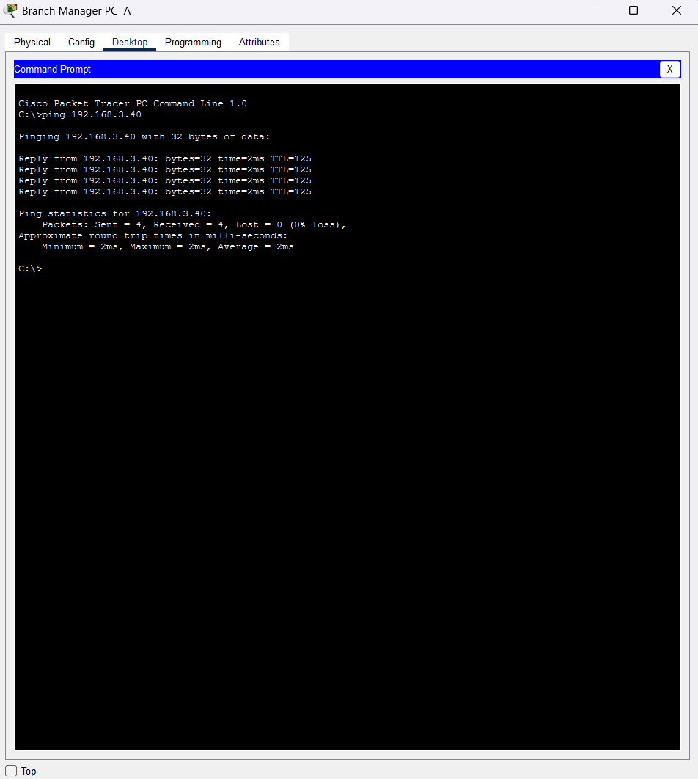

Figure 4. Branch Manager PC A: successful ping to Branch Manager PC B with 4/4 replies and 0% loss.

The supplied evidence therefore supports representative inter-branch connectivity after the OSPF configuration was completed.

_______________________________________________________________________

12. NUMERICAL CRC CALCULATION

12.1 Given Data
Parameter | Value
Data bits | 1101011011
Generator polynomial | 10011
Generator length | 5 bits
Generator degree | 4

12.2 Append Zeros
The generator has degree 4, so four zeros are appended to the data:
Original data : 1101011011
Append 4 zeros: 11010110110000

12.3 Modulo-2 Division
CRC division uses XOR instead of ordinary subtraction. The following compact sequence shows each 5-bit working window and the XOR operation.
Step | Working 5 bits | Operation | Result
1 | 11010 | 11010 ⊕ 10011 | 01001
2 | 10011 | 10011 ⊕ 10011 | 00000
3 | 00001 | Leading bit 0 → shift | 00001
4 | 00010 | Leading bit 0 → shift | 00010
5 | 00101 | Leading bit 0 → shift | 00101
6 | 01011 | Leading bit 0 → shift | 01011
7 | 10110 | 10110 ⊕ 10011 | 00101
8 | 01010 | Leading bit 0 → shift | 01010
9 | 10100 | 10100 ⊕ 10011 | 00111
10 | 01110 | Leading bit 0 → shift | 01110

After the final shift, the four-bit remainder is 1110. Therefore, the CRC is 1110 and the transmitted codeword is:
1101011011 + 1110 = 11010110111110

_______________________________________________________________________

13. RECEIVER CRC CHECK AND ERROR DEMONSTRATION

13.1 Correct Frame
The receiver divides the complete codeword by the same generator.
Received codeword = 11010110111110
Generator = 10011
Remainder = 0000
Because the remainder is 0000, no transmission error is detected and the frame is accepted.
13.2 One-Bit Error
To demonstrate error detection, the first bit of the codeword is changed from 1 to 0.
Original : 11010110111110
Corrupted: 01010110111110
Recalculating the CRC with generator 10011 gives a non-zero remainder:

Step | Working 5 bits | Operation | Result
1 | 01010 | Leading bit 0 → shift | 01010
2 | 10101 | 10101 ⊕ 10011 | 00110
3 | 01101 | Leading bit 0 → shift | 01101
4 | 11010 | 11010 ⊕ 10011 | 01001
5 | 10011 | 10011 ⊕ 10011 | 00000
6 | 00001 | Leading bit 0 → shift | 00001
7 | 00011 | Leading bit 0 → shift | 00011
8 | 00111 | Leading bit 0 → shift | 00111
9 | 01111 | Leading bit 0 → shift | 01111
10 | 11110 | 11110 ⊕ 10011 | 01101

The resulting remainder is 1101. Since 1101 is not equal to 0000, the receiver detects corruption. The frame is rejected and a reliable retransmission mechanism should obtain the correct data.
13.3 Accept/Reject Decision
Case | Codeword | CRC Remainder | Decision
No error | 11010110111110 | 0000 | ACCEPTED
One-bit error | 01010110111110 | 1101 | REJECTED

CRC remainder = 0000 → ACCEPT
CRC remainder ≠ 0000 → REJECT → retransmission

_______________________________________________________________________

14. RELIABILITY AND SECURITY INTEGRATION

14.1 Layered Reliability
• Link layer: CRC helps detect accidental frame corruption.
• Transport layer: TCP supports reliable delivery using acknowledgements, sequence numbers, retransmissions, timers, checksums, flow control, and congestion control.
• Application/web layer: HTTPS uses TLS to protect confidentiality, authentication, and cryptographic integrity.
14.2 Banking Security
• Integrity: changes to data should be detected.
• Confidentiality: sensitive information should not be readable by unauthorized users.
• Authentication: the communicating parties and users should be verified.
• Access control: ACLs and firewalls should restrict unnecessary traffic.
• Availability: redundancy, monitoring, and disaster recovery should keep services available.
In this project, the mechanisms form a layered defense. CRC provides local error detection, TCP provides reliable transport, and TLS provides cryptographic protection for application data. OSPF contributes dependable network-layer reachability by dynamically learning the remote LAN routes.
These mechanisms are complementary rather than interchangeable: CRC is not a security mechanism against an attacker, while TLS is designed to protect application communication from unauthorized observation or modification.
14.3 Relation to the Implemented Network
The Packet Tracer network represents the banking infrastructure across the Head Office, Branch A, and Branch B. The three LANs are connected through two serial WAN links and OSPF. The CRC calculation and error demonstration represent the detection of accidental data corruption, while the TCP and TLS discussion explains how reliable and secure application communication would operate over this routed network.

_______________________________________________________________________

15. REAL-LIFE OBSERVATIONS
• Banking transactions are sensitive because even a small change can affect the transaction result.
• Network data can be lost, delayed, duplicated, or corrupted during transmission.
• TCP uses acknowledgements and retransmissions for reliable application delivery.
• Timeouts help detect missing acknowledgements.
• Transaction logs allow important operations to be traced and checked.
• TLS protects banking communication through encryption and cryptographic integrity.
• Redundant servers and network devices can improve service availability.
• Monitoring can detect repeated failures, unusual traffic, and possible security incidents.
• Retransmitted requests must be handled carefully so that the same transaction is not processed twice.
• Reliable banking communication depends on several technologies working together, not one mechanism alone.

16. CONCLUSION
This PBL assignment demonstrated how reliable data transfer can be studied and modeled in an online banking environment. The practical network was designed in Cisco Packet Tracer using one Head Office and two branch offices. Three LANs were connected through two serial WAN links, and OSPF was configured so that the routers could exchange routes dynamically. The supplied verification results show successful WAN communication, reachable local gateways, and representative end-to-end connectivity between the three LANs.
The numerical CRC problem was also solved. For data 1101011011 and generator 10011, the CRC remainder is 1110 and the transmitted codeword is 11010110111110. The correct codeword produces a receiver remainder of 0000 and is accepted. After changing one bit, the receiver obtains a remainder of 1101, so the frame is rejected. This demonstrates how accidental transmission errors can be detected before corrupted data is accepted.
In an online banking environment, reliable communication cannot depend on one mechanism alone. CRC helps detect transmission corruption, TCP supports dependable delivery through acknowledgements and retransmission, and TLS protects sensitive application data through encryption and cryptographic integrity. Access control, logging, monitoring, backup, and careful handling of retransmitted requests add further operational protection. The project therefore connects the numerical CRC exercise with the practical routed network and with the layered reliability and security requirements of banking communication.

_______________________________________________________________________

17. FUTURE SCOPE
• Add more branch offices and LANs to make the banking network larger and more realistic.
• Add redundant routers and WAN links so communication can continue if one link fails.
• Configure advanced ACL rules to control access between banking departments and servers.
• Add firewalls to provide stronger protection for the banking network.
• Configure DHCP and DNS services to make IP management and name resolution easier.
• Improve OSPF configuration by using multiple areas and studying route redundancy.
• Add server backup and recovery mechanisms to improve the availability of banking services.
• Perform more network testing and monitoring, including link-failure, packet-loss, and connectivity checks.
• Extend the CRC and reliability study to include more transmission-error and retransmission cases.
• Introduce secure application communication using HTTPS/TLS in a complete banking-server simulation.

18. REFERENCES
[1] J. F. Kurose and K. W. Ross, Computer Networking: A Top-Down Approach, 8th ed. Boston, MA, USA: Pearson, 2021.
[2] A. S. Tanenbaum and D. Wetherall, Computer Networks, 6th ed. Boston, MA, USA: Pearson, 2021.
[3] W. Stallings, Data and Computer Communications, 10th ed. Upper Saddle River, NJ, USA: Pearson, 2013.
[4] W. Eddy, Ed., “Transmission Control Protocol (TCP),” RFC 9293, Internet Engineering Task Force, Aug. 2022.
[5] J. Postel, “Internet Protocol,” RFC 791, Internet Engineering Task Force, Sep. 1981.
[6] E. Rescorla, “The Transport Layer Security (TLS) Protocol Version 1.3,” RFC 8446, Internet Engineering Task Force, Aug. 2018.
[7] J. Postel, “Transmission Control Protocol,” RFC 793, Internet Engineering Task Force, Sep. 1981.
[8] Cisco Systems, Inc., Cisco IOS Security Configuration Guide: Securing Networks with ACLs. San Jose, CA, USA: Cisco Systems, Inc., 2024.
[9] Cisco Networking Academy, Cisco Packet Tracer. San Jose, CA, USA: Cisco Systems, Inc., 2024.
[10] P. Koopman, “32-bit cyclic redundancy codes for Internet applications,” in Proc. Int. Conf. Dependable Systems and Networks (DSN), Florence, Italy, 2002, pp. 459–468.

